SOURCE CODE:
Activity_main.xml
<?xml version="1.0" encoding="utf-8"?>
<LinearLayout xmlns:android="http://schemas.android.com/apk/res/android" android:layout_width="match_parent" android:layout_height="wrap_content"
android:orientation="vertical" android:layout_margin="50dp" android:layout_gravity="center">
<TextView
android:id="@+id/text1" android:layout_width="match_parent" android:layout_height="wrap_content" android:layout_margin="30dp" android:gravity="center"
android:text="Hello World!!! Welcome to MAD LAB !!!" android:textSize="30dp" android:textColor="@color/black"/>
<Button
android:id="@+id/button1" android:layout_width="wrap_content" android:layout_height="wrap_content" android:layout_gravity="center"

android:text="Click to view the change" android:gravity="center"/>

</LinearLayout>

Mainactivity.java
package com.example.hello_world;
import androidx.appcompat.app.AppCompatActivity; import android.graphics.Color;
import android.os.Bundle; import android.view.View; import android.widget.Button; import android.widget.TextView;
public class MainActivity extends AppCompatActivity { @Override
protected void onCreate(Bundle savedInstanceState) {
super.onCreate(savedInstanceState); setContentView(R.layout.activity_main);
TextView t= (TextView) findViewById(R.id.text1); Button B= (Button) findViewById(R.id.button1);

B.setOnClickListener(new View.OnClickListener() { @Override
public void onClick(View view) { t.setTextColor(Color.orange);

}
});
}
}

OUTPUT:
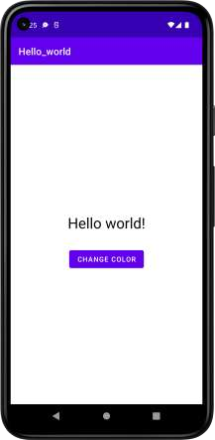
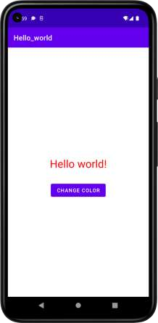
SOURCE CODE:

MainActivity.xml:

<?xml version="1.0" encoding="utf-8"?>
<RelativeLayout xmlns:android="http://schemas.android.com/apk/res/android" android:layout_width="match_parent" android:layout_height="match_parent">
<ImageView
android:layout_width="match_parent" android:layout_height="match_parent" android:id="@+id/imageView" />
</RelativeLayout>

MainActivity.java:

package com.example.exno4; import android.app.Activity; import android.graphics.Bitmap; import android.graphics.Canvas; import android.graphics.Color; import android.graphics.Paint;
import android.graphics.drawable.BitmapDrawable; import android.os.Bundle;
import android.widget.ImageView;

public class MainActivity extends Activity
{
@Override
public void onCreate(Bundle savedInstanceState)
{
super.onCreate(savedInstanceState); setContentView(R.layout.activity_main);

//Creating a Bitmap
Bitmap bg = Bitmap.createBitmap(720, 1280, Bitmap.Config.ARGB_8888);

//Setting the Bitmap as background for the ImageView ImageView i = (ImageView) findViewById(R.id.imageView); i.setBackgroundDrawable(new BitmapDrawable(bg));

//Creating the Canvas Object Canvas canvas = new Canvas(bg);

//Creating the Paint Object and set its color & TextSize Paint paint = new Paint();
paint.setColor(Color.BLUE); paint.setTextSize(50);

canvas.drawText("Rectangle", 420, 150, paint);
canvas.drawRect(400, 200, 650, 700, paint);
canvas.drawText("Circle", 120, 150, paint);
canvas.drawCircle(200, 350, 150, paint);
canvas.drawText("Square", 120, 800, paint);
canvas.drawRect(50, 850, 350, 1150, paint);
canvas.drawText("Line", 480, 800, paint);
canvas.drawLine(520, 850, 520, 1150, paint);
}

}

OUTPUT:
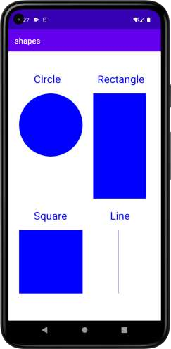

SOURCE CODE:

Activity_main.xml:
<?xml version="1.0" encoding="utf-8"?>
<RelativeLayout xmlns:android="http://schemas.android.com/apk/res/android"
xmlns:tools="http://schemas.android.com/tools" android:layout_width="match_parent" android:layout_height="match_parent" tools:context=".MainActivity">
<LinearLayout
android:layout_width="match_parent" android:layout_height="100dp">
<TextView
android:id="@+id/textView" android:layout_width="match_parent" android:layout_height="wrap_content" android:layout_margin="30dp" android:text="Details Form" android:textSize="25sp" android:gravity="center"/>
</LinearLayout>
<GridLayout
android:id="@+id/gridLayout" android:layout_width="match_parent" android:layout_height="match_parent" android:layout_marginTop="100dp" android:layout_marginBottom="200dp" android:columnCount="2" android:rowCount="3">
<TextView
android:id="@+id/textView1" android:layout_width="wrap_content" android:layout_height="wrap_content" android:layout_margin="10dp" android:layout_row="0" android:layout_column="0" android:text="Name" android:textSize="20sp" android:gravity="center"/>
<EditText
android:id="@+id/editText" android:layout_width="wrap_content" android:layout_height="wrap_content" android:layout_margin="10dp" android:layout_row="0"

android:layout_column="1" android:ems="10"/>
<TextView
android:id="@+id/textView2" android:layout_width="wrap_content" android:layout_height="wrap_content" android:layout_margin="10dp" android:layout_row="1" android:layout_column="0" android:text="Reg.No" android:textSize="20sp" android:gravity="center"/>
<EditText
android:id="@+id/editText2" android:layout_width="wrap_content" android:layout_height="wrap_content" android:layout_margin="10dp" android:layout_row="1" android:layout_column="1" android:inputType="number" android:ems="10"/>
<TextView
android:id="@+id/textView3" android:layout_width="wrap_content" android:layout_height="wrap_content" android:layout_margin="10dp" android:layout_row="2" android:layout_column="0" android:text="Dept" android:textSize="20sp" android:gravity="center"/>
<Spinner
android:id="@+id/spinner" android:layout_width="wrap_content" android:layout_height="wrap_content" android:layout_margin="10dp" android:layout_row="2" android:layout_column="1" android:spinnerMode="dropdown"/>
</GridLayout>
<Button
android:id="@+id/button" android:layout_width="wrap_content" android:layout_height="wrap_content" android:layout_alignParentBottom="true" android:layout_centerInParent="true" android:layout_marginBottom="150dp" android:text="Submit"/>

</RelativeLayout>

Activity_second.xml:
<?xml version="1.0" encoding="utf-8"?>
<LinearLayout xmlns:android="http://schemas.android.com/apk/res/android "
xmlns:tools="http://schemas.android.com/tools" android:layout_width="match_parent" android:layout_height="match_parent" tools:context="com.example.exno2.SecondActivity" android:orientation="vertical" android:gravity="center">
<TextView
android:id="@+id/textView1" android:layout_width="wrap_content" android:layout_height="wrap_content" android:layout_margin="20dp" android:text="New Text" android:textSize="30sp"/>
<TextView
android:id="@+id/textView2" android:layout_width="wrap_content" android:layout_height="wrap_content" android:layout_margin="20dp" android:text="New Text" android:textSize="30sp"/>
<TextView
android:id="@+id/textView3" android:layout_width="wrap_content" android:layout_height="wrap_content" android:layout_margin="20dp" android:text="New Text" android:textSize="30sp"/>
</LinearLayout>

MainActivity.java
package com.example.exno2; import android.content.Intent;
import android.support.v7.app.AppCompatActivity; import android.os.Bundle;
import android.view.View;
import android.widget.ArrayAdapter; import android.widget.Button; import android.widget.EditText; import android.widget.Spinner;
public class MainActivity extends AppCompatActivity {

//Defining the Views

EditText e1,e2; Button bt; Spinner s;

//Data for populating in Spinner String []
dept_array={"CSE","ECE","IT","Mech","Civil"}; String name,reg,dept;
@Override
protected void onCreate(Bundle savedInstanceState) { super.onCreate(savedInstanceState); setContentView(R.layout.activity_main);

//Referring the Views
e1= (EditText) findViewById(R.id.editText); e2= (EditText) findViewById(R.id.editText2); bt= (Button) findViewById(R.id.button);

s= (Spinner) findViewById(R.id.spinner);
//Creating Adapter for Spinner for adapting the data from array to Spinner
ArrayAdapter adapter= new ArrayAdapter(MainActivity.this,android.R.layout.simple_sp inner_item,dept_array);
s.setAdapter(adapter);

//Creating Listener for Button bt.setOnClickListener(new View.OnClickListener()
{
@Override
public void onClick(View v) {
//Getting the Values from Views(Edittext
& Spinner)

name=e1.getText().toString(); reg=e2.getText().toString(); dept=s.getSelectedItem().toString();

//Intent For Navigating to Second
Activity

Intent i = new Intent (MainActivity.this,SecondActivity.class);

//For Passing the Values to Second
Activity

i.putExtra("name_key", name); i.putExtra("reg_key",reg); i.putExtra("dept_key", dept);

startActivity(i);

}

});
}
}

SecondActivity.java
package com.example.exno2; import android.content.Intent;
import android.support.v7.app.AppCompatActivity; import android.os.Bundle;
import android.widget.TextView;
public class SecondActivity extends AppCompatActivity { TextView t1,t2,t3;
String name,reg,dept; @Override
protected void onCreate(Bundle savedInstanceState) { super.onCreate(savedInstanceState); setContentView(R.layout.activity_second);

t1= (TextView) findViewById(R.id.textView1); t2= (TextView) findViewById(R.id.textView2); t3= (TextView) findViewById(R.id.textView3);

//Getting the Intent Intent i = getIntent();

//Getting the Values from First Activity using the Intent received
name=i.getStringExtra("name_key"); reg=i.getStringExtra("reg_key"); dept=i.getStringExtra("dept_key");

//Setting the Values to Intent t1.setText(name); t2.setText(reg); t3.setText(dept);
}
}

OUTPUT:

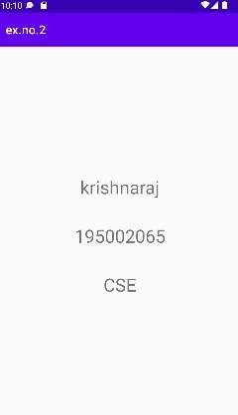
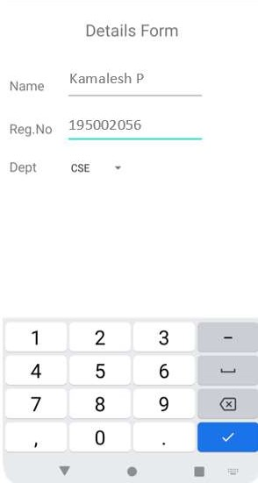
Kamalesh P 195002056 CSE
SOURCE CODE:

MainActivity.java
package com.example.myapplication; import android.app.Activity;
import android.app.AlertDialog.Builder; import android.content.Context;
import android.database.Cursor;
import android.database.sqlite.SQLiteDatabase; import android.os.Bundle;
import android.view.View;
import android.view.View.OnClickListener; import android.widget.Button;
import android.widget.EditText;

public class MainActivity extends Activity implements OnClickListener
{
EditText Rollno,Name,Marks;
Button Insert,Delete,Update,View,ViewAll; SQLiteDatabase db;
/** Called when the activity is first created. */ @Override
public void onCreate(Bundle savedInstanceState)
{
super.onCreate(savedInstanceState); setContentView(R.layout.activity_main); Rollno=(EditText)findViewById(R.id.Rollno); Name=(EditText)findViewById(R.id.Name); Marks=(EditText)findViewById(R.id.Marks); Insert=(Button)findViewById(R.id.Insert); Delete=(Button)findViewById(R.id.Delete); Update=(Button)findViewById(R.id.Update); View=(Button)findViewById(R.id.View); ViewAll=(Button)findViewById(R.id.ViewAll); Insert.setOnClickListener(this); Delete.setOnClickListener(this); Update.setOnClickListener(this); View.setOnClickListener(this); ViewAll.setOnClickListener(this);
// Creating database and table
db=openOrCreateDatabase("StudentDB", Context.MODE_PRIVATE, null); db.execSQL("CREATE TABLE IF NOT EXISTS student(rollno VARCHAR,name
VARCHAR,marks VARCHAR);");
}
public void onClick(View view)
{
// Inserting a record to the Student table if(view==Insert)
{
// Checking for empty fields if(Rollno.getText().toString().trim().length()==0||
Name.getText().toString().trim().length()==0|| Marks.getText().toString().trim().length()==0)
{
showMessage("Error", "Please enter all values"); return;
}
db.execSQL("insert into students ('"+Rollno.getText()+"','"+Name.getText()+ "','"+Marks.getText()+"');");
showMessage("Success", "Record added"); clearText();
}
// Deleting a record from the Student table if(view==Delete)
{
// Checking for empty roll number if(Rollno.getText().toString().trim().length()==0)
{
showMessage("Error", "Please enter Rollno"); return;
}

null);
Cursor c=db.rawQuery("SELECT * FROM student WHERE rollno='"+Rollno.getText()+"'",

if(c.moveToFirst())
{

db.execSQL("DELETE FROM student WHERE rollno='"+Rollno.getText()+"'"); showMessage("Success", "Record Deleted");
}
else
{

showMessage("Error", "Invalid Rollno");
}
clearText();
}
// Updating a record in the Student table if(view==Update)
{
// Checking for empty roll number if(Rollno.getText().toString().trim().length()==0)
{
showMessage("Error", "Please enter Rollno"); return;
}

null);
Cursor c=db.rawQuery("SELECT * FROM student WHERE rollno='"+Rollno.getText()+"'",

if(c.moveToFirst()) {
db.execSQL("UPDATE student SET name='" + Name.getText() + "',marks='" +

Marks.getText() +
"' WHERE rollno='"+Rollno.getText()+"'"); showMessage("Success", "Record Modified");
}
else {
showMessage("Error", "Invalid Rollno");
}
clearText();
}
// Display a record from the Student table if(view==View)
{
// Checking for empty roll number if(Rollno.getText().toString().trim().length()==0)
{
showMessage("Error", "Please enter Rollno"); return;
}

null);
Cursor c=db.rawQuery("SELECT * FROM student WHERE rollno='"+Rollno.getText()+"'",

if(c.moveToFirst())
{

Name.setText(c.getString(1)); Marks.setText(c.getString(2));

}
else
{
showMessage("Error", "Invalid Rollno"); clearText();
}
}
// Displaying all the records if(view==ViewAll)
{
Cursor c=db.rawQuery("SELECT * FROM student", null); if(c.getCount()==0)
{
showMessage("Error", "No records found"); return;
}
StringBuffer buffer=new StringBuffer(); while(c.moveToNext())
{
buffer.append("Rollno: "+c.getString(0)+"\n"); buffer.append("Name: "+c.getString(1)+"\n"); buffer.append("Marks: "+c.getString(2)+"\n\n");
}
showMessage("Student Details", buffer.toString());
}
}
public void showMessage(String title,String message)
{
Builder builder=new Builder(this); builder.setCancelable(true); builder.setTitle(title); builder.setMessage(message); builder.show();
}
public void clearText()
{
Rollno.setText("");
Name.setText("");
Marks.setText(""); Rollno.requestFocus();

}
}

activity_main.xml:
<?xml version="1.0" encoding="utf-8"?>
<AbsoluteLayout xmlns:android="http://schemas.android.com/apk/res/android" android:layout_width="match_parent" android:layout_height="match_parent">
<TextView android:layout_width="wrap_content" android:layout_height="wrap_content" android:layout_x="50dp" android:layout_y="20dp" android:text="Student Details" android:textSize="30sp" />

<TextView android:layout_width="wrap_content" android:layout_height="wrap_content" android:layout_x="20dp" android:layout_y="110dp" android:text="Enter Rollno:" android:textSize="20sp" />
<EditText android:id="@+id/Rollno" android:layout_width="150dp"
android:layout_height="wrap_content" android:layout_x="175dp" android:layout_y="100dp" android:inputType="number" android:textSize="20sp" />
<TextView android:layout_width="wrap_content" android:layout_height="wrap_content" android:layout_x="20dp" android:layout_y="160dp" android:text="Enter Name:" android:textSize="20sp" />
<EditText android:id="@+id/Name" android:layout_width="150dp"
android:layout_height="wrap_content" android:layout_x="175dp" android:layout_y="150dp" android:inputType="text" android:textSize="20sp" />
<TextView android:layout_width="wrap_content" android:layout_height="wrap_content" android:layout_x="20dp" android:layout_y="210dp"
android:text="Enter Marks:" android:textSize="20sp" />

<EditText android:id="@+id/Marks" android:layout_width="150dp"
android:layout_height="wrap_content" android:layout_x="175dp" android:layout_y="200dp" android:inputType="number" android:textSize="20sp" />

<Button
android:id="@+id/Insert" android:layout_width="150dp" android:layout_height="wrap_content" android:layout_x="25dp" android:layout_y="300dp" android:text="Insert" android:textSize="30dp" />
<Button
android:id="@+id/Delete" android:layout_width="150dp" android:layout_height="wrap_content" android:layout_x="200dp" android:layout_y="300dp" android:text="Delete" android:textSize="30dp" />
<Button
android:id="@+id/Update" android:layout_width="150dp" android:layout_height="wrap_content" android:layout_x="25dp" android:layout_y="400dp" android:text="Update" android:textSize="30dp" />
<Button
android:id="@+id/View" android:layout_width="150dp" android:layout_height="wrap_content" android:layout_x="200dp" android:layout_y="400dp" android:text="View" android:textSize="30dp" />

<Button
android:id="@+id/ViewAll" android:layout_width="200dp" android:layout_height="wrap_content" android:layout_x="100dp" android:layout_y="500dp" android:text="View All"
android:textSize="30dp" />

</AbsoluteLayout>

OUTPUT: Inserting data into the database
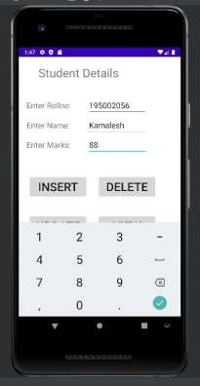
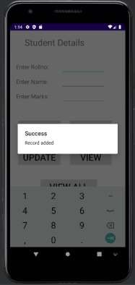
Update data:
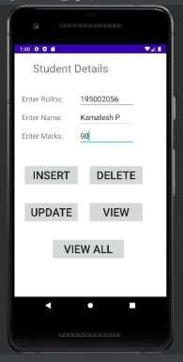
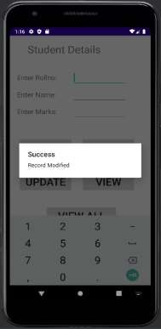

View data
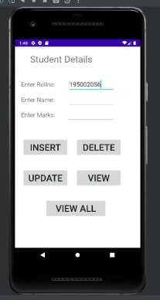
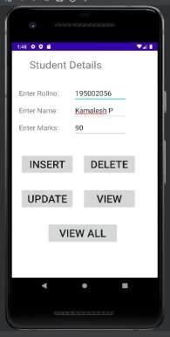

View all:
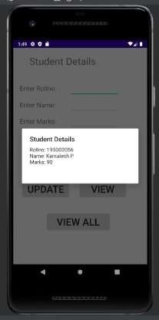

Invalid roll no:
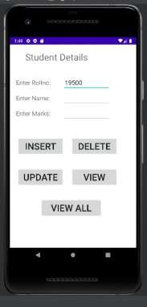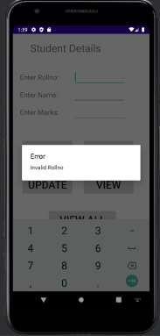

Deletion:
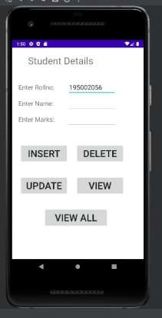
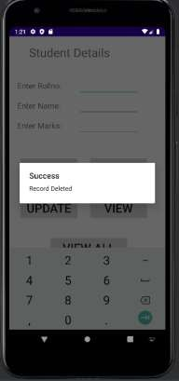

After deleting the record:
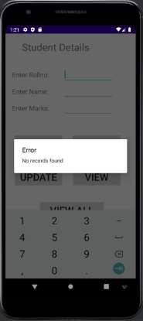

SOURCE CODE:
Acitivity_main.xml
<?xml version="1.0" encoding="utf-8"?>
<LinearLayout xmlns:android="http://schemas.android.com/apk/res/android" android:orientation="vertical" android:layout_width="match_parent" android:layout_height="match_parent" android:layout_margin="20dp">
<LinearLayout android:id="@+id/linearLayout1" android:layout_width="match_parent" android:layout_height="wrap_content" android:layout_margin="20dp">
<EditText android:id="@+id/editText1"
android:layout_width="match_parent" android:layout_height="wrap_content" android:layout_weight="1" android:inputType="numberDecimal" android:textSize="20sp" />
<EditText android:id="@+id/editText2"
android:layout_width="match_parent" android:layout_height="wrap_content" android:layout_weight="1" android:inputType="numberDecimal" android:textSize="20sp" />
</LinearLayout>
<LinearLayout android:id="@+id/linearLayout2" android:layout_width="match_parent" android:layout_height="wrap_content" android:layout_margin="20dp">
<Button
android:id="@+id/Add" android:layout_width="match_parent" android:layout_height="wrap_content" android:layout_weight="1" android:text="+" android:textSize="30sp"/>
<Button
android:id="@+id/Sub" android:layout_width="match_parent" android:layout_height="wrap_content" android:layout_weight="1" android:text="-" android:textSize="30sp"/>
<Button
android:id="@+id/Mul" android:layout_width="match_parent" android:layout_height="wrap_content" android:layout_weight="1" android:text="*"
android:textSize="30sp"/>
<Button
android:id="@+id/Div" android:layout_width="match_parent" android:layout_height="wrap_content" android:layout_weight="1" android:text="/" android:textSize="30sp"/>
</LinearLayout>
<TextView android:id="@+id/textView"
android:layout_width="match_parent" android:layout_height="wrap_content" android:layout_marginTop="50dp" android:text="Answer is" android:textSize="30sp" android:gravity="center"/>
</LinearLayout>

MainActivity.java
package com.example.calculator; import android.os.Bundle;
import android.text.TextUtils; import android.view.View;
import android.view.View.OnClickListener; import android.widget.Button;
import android.widget.EditText; import android.widget.TextView;
import androidx.appcompat.app.AppCompatActivity;
//import androidx.appcompat.app.AppCompatActivity;
public class MainActivity extends AppCompatActivity implements OnClickListener
{
//Defining the Views EditText Num1; EditText Num2; Button Add;
Button Sub; Button Mul; Button Div; TextView Result;
@Override
public void onCreate(Bundle savedInstanceState)
{
super.onCreate(savedInstanceState); setContentView(R.layout.activity_main);
//Referring the Views
Num1 = (EditText) findViewById(R.id.editText1); Num2 = (EditText) findViewById(R.id.editText2); Add = (Button) findViewById(R.id.Add);
Sub = (Button) findViewById(R.id.Sub);
Mul = (Button) findViewById(R.id.Mul); Div = (Button) findViewById(R.id.Div);
Result = (TextView) findViewById(R.id.textView);
// set a listener Add.setOnClickListener(this); Sub.setOnClickListener(this); Mul.setOnClickListener(this); Div.setOnClickListener(this);
}
@Override
public void onClick (View v)
{
float num1 = 0; float num2 = 0; float result = 0;
String oper = "";
// check if the fields are empty
if (TextUtils.isEmpty(Num1.getText().toString()) ||TextUtils.isEmpty(Num2.getText().toString())) return;
// read EditText and fill variables with numbers num1 = Float.parseFloat(Num1.getText().toString()); num2 = Float.parseFloat(Num2.getText().toString());
// defines the button that has been clicked and performs the corresponding operation
// write operation into oper, we will use it later for output switch (v.getId())
{
case R.id.Add: oper = "+";
result = num1 + num2; break;
case R.id.Sub: oper = "-";
result = num1 - num2; break;
case R.id.Mul: oper = "*";
result = num1 * num2; break;
case R.id.Div: oper = "/";
result = num1 / num2; break;
default:
break;
}
// form the output line
Result.setText(num1 + " " + oper + " " + num2 + " = " + result);
}
}

OUTPUT:

Addition Subtraction
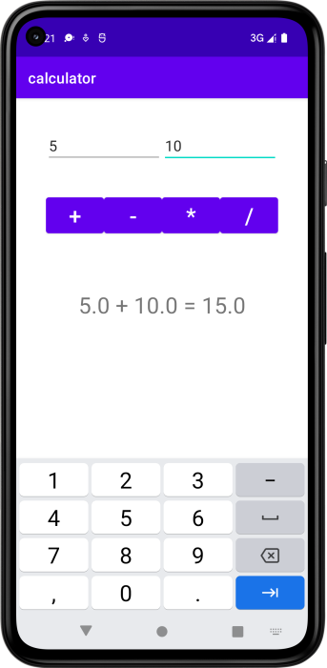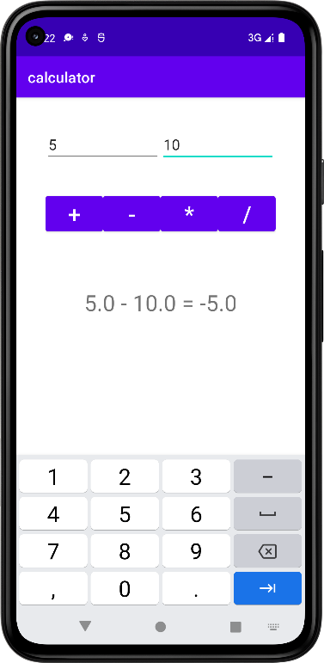

Multiplication Division
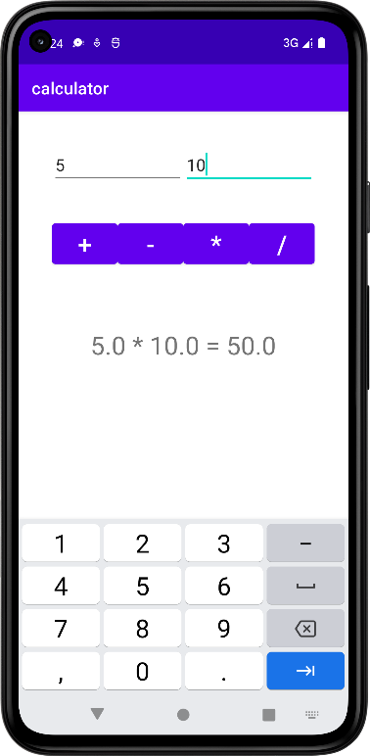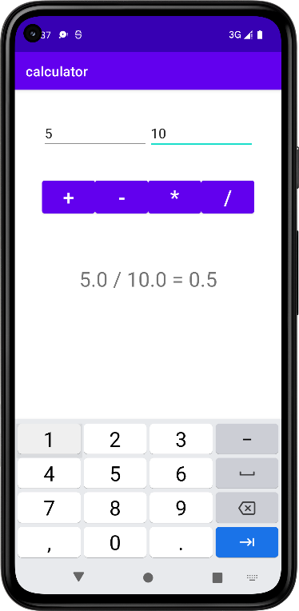

SOURCE CODE:
MainActivity.java
packagecom.example.myapplication;
importandroid.app.ListActivity;
importandroid.content.Intent;
importandroid.net.Uri;
importandroid.os.AsyncTask;
importandroid.os.Bundle;
importandroid.view.View;
importandroid.widget.ArrayAdapter;
importandroid.widget.ListView;
import org.xmlpull.v1.XmlPullParser;
import org.xmlpull.v1.XmlPullParserException;
import org.xmlpull.v1.XmlPullParserFactory;
importjava.io.IOException;
importjava.io.InputStream;
importjava.net.MalformedURLException;
import java.net.URL;
importjava.util.ArrayList;
importjava.util.List;
public class MainActivity extends ListActivity
{
List headlines;
List links;
@Override
protected void onCreate(Bundle savedInstanceState)
{
super.onCreate(savedInstanceState);
newMyAsyncTask().execute();
}
classMyAsyncTask extends AsyncTask<Object,Void,ArrayAdapter>
{
@Override
protectedArrayAdapterdoInBackground(Object[] params)
{
headlines = new ArrayList();
links = new ArrayList();
try
{
URL url = new URL("https://codingconnect.net/feed");
XmlPullParserFactory factory = XmlPullParserFactory.newInstance();
factory.setNamespaceAware(false);
XmlPullParserxpp = factory.newPullParser();
xpp.setInput(getInputStream(url), "UTF_8");
booleaninsideItem = false;
inteventType = xpp.getEventType();
while (eventType != XmlPullParser.END_DOCUMENT)
{

if (eventType == XmlPullParser.START_TAG)
{
if (xpp.getName().equalsIgnoreCase("item"))
{
insideItem = true;
}
else if (xpp.getName().equalsIgnoreCase("title"))
{
if (insideItem)
headlines.add(xpp.nextText()); //extract the headline
}
else if (xpp.getName().equalsIgnoreCase("link"))
{
if (insideItem)
links.add(xpp.nextText()); //extract the link of article
}
}
else if(eventType==XmlPullParser.END_TAG&&xpp.getName().equalsIgnoreCase("item"))
{
insideItem=false;
}
eventType = xpp.next(); //move to next element
}
}
catch (MalformedURLException e)
{
e.printStackTrace();
}
catch (XmlPullParserException e)
{
e.printStackTrace();
}
catch (IOException e)
{
e.printStackTrace();
}
return null;
}
protected void onPostExecute(ArrayAdapter adapter)
{
adapter = new ArrayAdapter(MainActivity.this, android.R.layout.simple_list_item_1, headlines);
setListAdapter(adapter);
}
}
@Override
protected void onListItemClick(ListView l, View v, int position, long id)
{

Uri uri = Uri.parse((links.get(position)).toString());
Intent intent = new Intent(Intent.ACTION_VIEW, uri);
startActivity(intent);
}
publicInputStreamgetInputStream(URL url)
{
try
{
returnurl.openConnection().getInputStream();
}
catch (IOException e)
{
return null;
}
}
}

Activity_main.xml:
<?xml version="1.0" encoding="utf-8"?>
<LinearLayoutxmlns:android="http://schemas.android.com/apk/res/android"
android:layout_width="fill_parent"
android:layout_height="fill_parent"
android:orientation="vertical" >

<ListView
android:id="@+id/listView"
android:layout_width="match_parent"
android:layout_height="wrap_content" />
</LinearLayout>

AndroidManifest.xml
<?xml version="1.0" encoding="utf-8"?>
<manifest xmlns:android="http://schemas.android.com/apk/res/android"
package="com.example.myapplication">
<uses-permissionandroid:name="android.permission.INTERNET"/>
<application>
<activity
android:name=".MainActivity"
android:exported="true"
android:theme="@style/Theme.MyApplication">
<intent-filter>
<action android:name="android.intent.action.MAIN" />
<category android:name="android.intent.category.LAUNCHER" />
</intent-filter>
</activity>
</application>
</manifest>

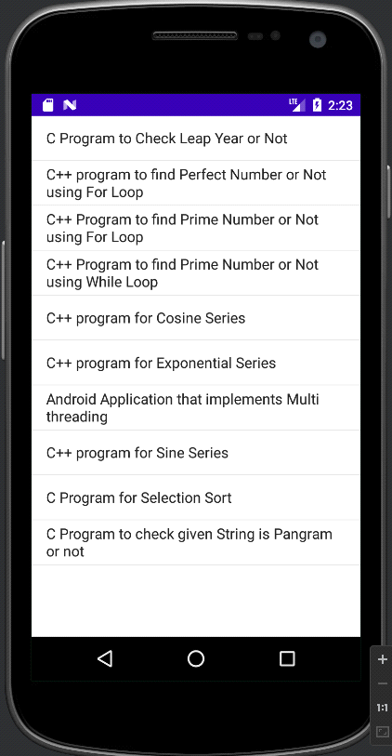
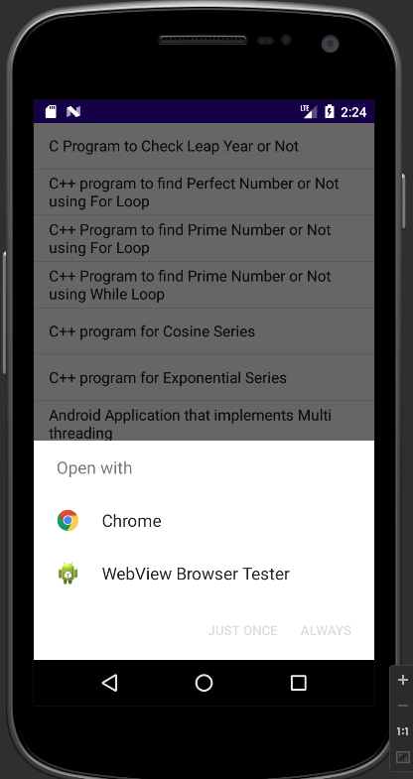
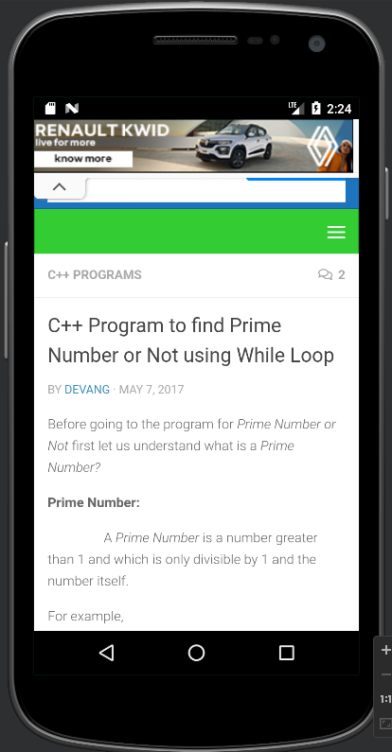
OUTPUT:

RESULT:
Thus, an application that uses RSS feed has been implemented successfully.

SOURCE CODE:
MainActivity.java
package com.example.myapplication;
import android.os.Bundle;
import androidx.appcompat.app.AppCompatActivity;
import android.view.View;
import android.widget.Button;
import android.widget.ImageView;
public class MainActivity extends AppCompatActivity
{
ImageViewimg;
Button bt1,bt2;
@Override
protected void onCreate(Bundle savedInstanceState)
{
super.onCreate(savedInstanceState);
setContentView(R.layout.activity_main);
bt1 = (Button)findViewById(R.id.button);
bt2= (Button) findViewById(R.id.button2);
img = (ImageView)findViewById(R.id.imageView);
bt1.setOnClickListener(new View.OnClickListener()
{
@Override
public void onClick(View v)
{
new Thread(new Runnable()
{
@Override
public void run()
{
img.post(new Runnable()
{
@Override
public void run()
{
img.setImageResource(R.drawable.india1);
}
});
}
}).start();
}
});
bt2.setOnClickListener(new View.OnClickListener()
{
@Override
public void onClick(View v)
{
new Thread(new Runnable()

{
@Override
public void run()
{
img.post(new Runnable()
{
@Override
public void run()
{
img.setImageResource(R.drawable.india2);
}
});
}
}).start();
}
});
}
}

activity_main.xml
<?xml version="1.0" encoding="utf-8"?>
<LinearLayoutxmlns:android="http://schemas.android.com/apk/res/android"
android:layout_width="match_parent"
android:layout_height="match_parent"
android:orientation="vertical" >
<ImageView
android:id="@+id/imageView"
android:layout_width="250dp"
android:layout_height="250dp"
android:layout_margin="50dp"
android:layout_gravity="center" />
<Button
android:id="@+id/button"
android:layout_width="wrap_content"
android:layout_height="wrap_content"
android:layout_margin="10dp"
android:layout_gravity="center"
android:text="Load Image 1" />
<Button
android:id="@+id/button2"
android:layout_width="wrap_content"
android:layout_height="wrap_content"
android:layout_margin="10dp"
android:layout_gravity="center"
android:text="Load image 2" />
</LinearLayout>

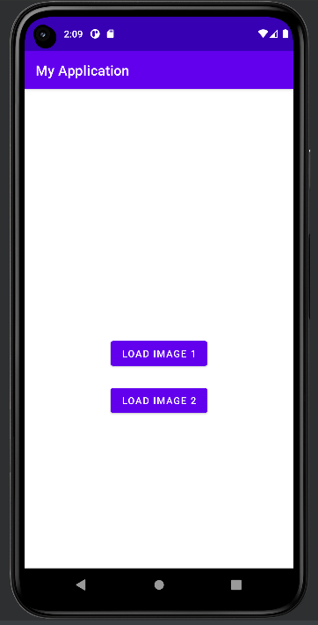
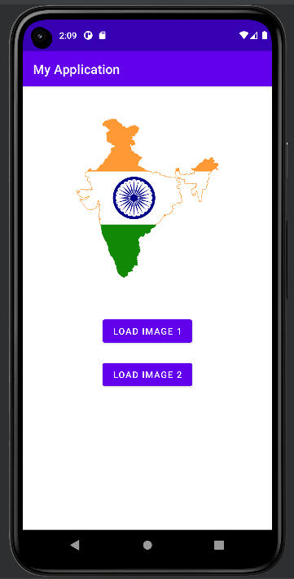
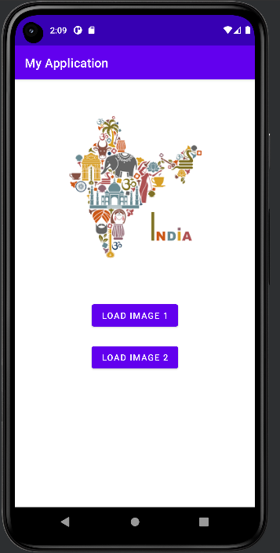
OUTPUT:

RESULT:
Thus, an application that implements multithreading has been implemented successfully.

SOURCE CODE:
Main_Activity.java
packagecom.example.myapplication;
importandroid.app.Activity;
importandroid.content.Context;
importandroid.location.Location;
importandroid.location.LocationListener;
importandroid.location.LocationManager;
importandroid.os.Bundle;
importandroid.view.View;
importandroid.view.View.OnClickListener;
importandroid.widget.Button;
importandroid.widget.Toast;
public class LbsGeocodingActivity extends Activity {
private static final long MINIMUM_DISTANCE_CHANGE_FOR_UPDATES = 1; // in Meters
private static final long MINIMUM_TIME_BETWEEN_UPDATES = 1000; // in Milliseconds
protectedLocationManagerlocationManager;
protected Button retrieveLocationButton;
@Override
public void onCreate(Bundle savedInstanceState) {
super.onCreate(savedInstanceState);
setContentView(R.layout.main);
retrieveLocationButton = (Button) findViewById(R.id.retrieve_location_button);
locationManager = (LocationManager) getSystemService(Context.LOCATION_SERVICE);
locationManager.requestLocationUpdates(
LocationManager.GPS_PROVIDER,
MINIMUM_TIME_BETWEEN_UPDATES,
MINIMUM_DISTANCE_CHANGE_FOR_UPDATES,
newMyLocationListener()
);
retrieveLocationButton.setOnClickListener(new OnClickListener() {
@Override
public void onClick(View v) {
showCurrentLocation();
}
});
}
protected void showCurrentLocation() {
Location location = locationManager.getLastKnownLocation(LocationManager.GPS_PROVIDER);
if (location != null) {
String message = String.format(
"Current Location \n Longitude: %1$s \n Latitude: %2$s",
location.getLongitude(), location.getLatitude()
);
Toast.makeText(LbsGeocodingActivity.this, message,
Toast.LENGTH_LONG).show();
}
}

private class MyLocationListener implements LocationListener {
public void onLocationChanged(Location location) {
String message = String.format(
"New Location \n Longitude: %1$s \n Latitude: %2$s",
location.getLongitude(), location.getLatitude()
);
Toast.makeText(LbsGeocodingActivity.this, message, Toast.LENGTH_LONG).show();
}
public void onStatusChanged(String s, inti, Bundle b) {
Toast.makeText(LbsGeocodingActivity.this, "Provider status changed",
Toast.LENGTH_LONG).show();
}
public void onProviderDisabled(String s) {
Toast.makeText(LbsGeocodingActivity.this,
"Provider disabled by the user. GPS turned off",
Toast.LENGTH_LONG).show();
}
public void onProviderEnabled(String s) {
Toast.makeText(LbsGeocodingActivity.this,
"Provider enabled by the user. GPS turned on",
Toast.LENGTH_LONG).show();
}
}
}
activity_main.xml
<?xml version="1.0" encoding="utf-8"?>
<LinearLayoutxmlns:android="http://schemas.android.com/apk/res/android"
android:orientation="vertical"
android:layout_width="fill_parent"
android:layout_height="fill_parent">
<Button
android:id="@+id/retrieve_location_button"
android:text="Retrieve Location"
android:layout_width="wrap_content"
android:layout_height="wrap_content"/>
</LinearLayout>

AndroidManifest.xml
<?xml version="1.0" encoding="utf-8"?>
<manifest xmlns:android="http://schemas.android.com/apk/res/android"
package="com.javaSOURCE CODEgeeks.android.lbs"
android:versionSOURCE CODE="1"
android:versionName="1.0">
<application android:icon="@drawable/icon" android:label="@string/app_name">
<activity android:name=".LbsGeocodingActivity"
android:label="@string/app_name">
<intent-filter>
<action android:name="android.intent.action.MAIN" />

<category android:name="android.intent.category.LAUNCHER" />
</intent-filter>
</activity>
</application>
<uses-permission android:name="android.permission.ACCESS_FINE_LOCATION" />
<uses-permission android:name="android.permission.ACCESS_MOCK_LOCATION" />
<uses-permission android:name="android.permission.ACCESS_COARSE_LOCATION" />
<uses-sdkandroid:minSdkVersion="3" />
</manifest>
OUTPUT:
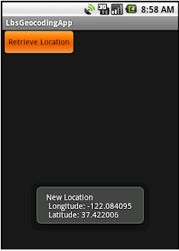
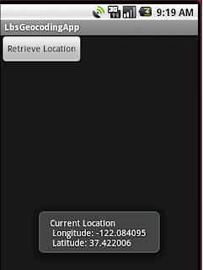

RESULT:
Thus, a native application that uses GPS location information has been implemented successfully.

SOURCE CODE:
MainActivity.java
packagecom.example.myapplication;
importandroid.os.Bundle;
importandroidx.appcomapt.app.AppCompatActivity;
importandroid.view.View;
importandroid.widget.Button;
importandroid.widget.EditText;
importandroid.widget.Toast;
importjava.io.BufferedReader;
importjava.io.File;
importjava.io.FileInputStream;
importjava.io.FileOUTPUTStream;
importjava.io.InputStreamReader;
public class MainActivity extends AppCompatActivity
{
EditText e1;
Button write,read,clear;
@Override
protected void onCreate(Bundle savedInstanceState)
{
super.onCreate(savedInstanceState);
setContentView(R.layout.activity_main);
e1= (EditText) findViewById(R.id.editText);
write= (Button) findViewById(R.id.button);
read= (Button) findViewById(R.id.button2);
clear= (Button) findViewById(R.id.button3);
write.setOnClickListener(new View.OnClickListener()
{
@Override
public void onClick(View v)
{
String message=e1.getText().toString();
try
{
File f=new File("/sdcard/myfile.txt");
f.createNewFile();
FileOUTPUTStreamfout=new FileOUTPUTStream(f);
fout.write(message.getBytes());
fout.close();
Toast.makeText(getBaseContext(),"Data Written in SDCARD",Toast.LENGTH_LONG).show();
}
catch (Exception e)
{
Toast.makeText(getBaseContext(),e.getMessage(),Toast.LENGTH_LONG).show();
}
}
});

read.setOnClickListener(new View.OnClickListener()
{
@Override
public void onClick(View v)
{
String message;
String buf = "";
try
{
File f = new File("/sdcard/myfile.txt");
FileInputStream fin = new FileInputStream(f);
BufferedReaderbr = new BufferedReader(new InputStreamReader(fin));
while ((message = br.readLine()) != null)
{
buf += message;
}
e1.setText(buf);
br.close();
fin.close();
Toast.makeText(getBaseContext(),"Data Recived from SDCARD",Toast.LENGTH_LONG).show();
}
catch (Exception e)
{
Toast.makeText(getBaseContext(), e.getMessage(), Toast.LENGTH_LONG).show();
}
}
});
clear.setOnClickListener(new View.OnClickListener()
{
@Override
public void onClick(View v)
{
e1.setText("");
}
});
}
}

activity_main.xml
<?xml version="1.0" encoding="utf-8"?>
<LinearLayoutxmlns:android="http://schemas.android.com/apk/res/android"
android:layout_width="match_parent"
android:layout_height="match_parent"
android:layout_margin="20dp"
android:orientation="vertical">
<EditText
android:id="@+id/editText"
android:layout_width="match_parent"

android:layout_height="wrap_content"
android:singleLine="true"
android:textSize="30dp" />
<Button
android:id="@+id/button"
android:layout_width="match_parent"
android:layout_height="wrap_content"
android:layout_margin="10dp"
android:text="Write Data"
android:textSize="30dp" />
<Button
android:id="@+id/button2"
android:layout_width="match_parent"
android:layout_height="wrap_content"
android:layout_margin="10dp"
android:text="Read data"
android:textSize="30dp" />
<Button
android:id="@+id/button3"
android:layout_width="match_parent"
android:layout_height="wrap_content"
android:layout_margin="10dp"
android:text="Clear"
android:textSize="30dp" />
</LinearLayout>

AndroidManifest.xml
<?xml version="1.0" encoding="utf-8"?>
<manifest xmlns:android="http://schemas.android.com/apk/res/android"
package="com.example.exno9" >
<uses-permission android:name="android.permission.WRITE_EXTERNAL_STORAGE"></uses-permission>
<application
android:allowBackup="true"
android:icon="@mipmap/ic_launcher"
android:label="@string/app_name"
android:supportsRtl="true"
android:theme="@style/AppTheme" >
<activity android:name=".MainActivity" >
<intent-filter>
<action android:name="android.intent.action.MAIN" />
<category android:name="android.intent.category.LAUNCHER" />
</intent-filter>
</activity>
</application>
</manifest>
OUTPUT:
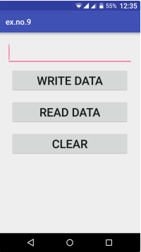
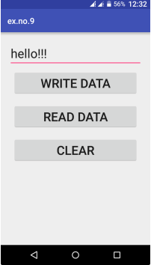
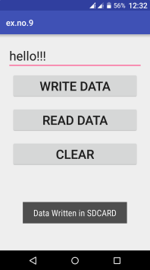
RESULT:
Thus, an android application that writes data to the SD card has been implemented successfully.

SOURCE CODE:
MainActivity.java
packagecom.example.myapplication;
importandroid.app.Notification;
importandroid.app.NotificationManager;
importandroid.app.PendingIntent;
importandroid.content.Intent;
importandroid.os.Bundle;
importandroidx.appcompat.app.AppCompatActivity;
importandroid.view.View;
importandroid.widget.Button;
importandroid.widget.EditText;
public class MainActivity extends AppCompatActivity
{
Button notify;
EditText e;
@Override
protected void onCreate(Bundle savedInstanceState)
{
super.onCreate(savedInstanceState);
setContentView(R.layout.activity_main);
notify= (Button) findViewById(R.id.button);
e= (EditText) findViewById(R.id.editText);
notify.setOnClickListener(new View.OnClickListener()
{
@Override
public void onClick(View v)
{
Intent intent = new Intent(MainActivity.this, SecondActivity.class);
PendingIntent pending = PendingIntent.getActivity(MainActivity.this, 0, intent, 0);
Notification noti = new Notification.Builder(MainActivity.this).setContentTitle("New Message").setContentText(e.getText().toString()).setSmallIcon(R.mipmap.ic_launcher).setContentIntent(pending).build();
NotificationManager manager = (NotificationManager) getSystemService(NOTIFICATION_SERVICE);
noti.flags |= Notification.FLAG_AUTO_CANCEL;
manager.notify(0, noti);
}
});
}
}
activity_main.xml
<?xml version="1.0" encoding="utf-8"?>
<LinearLayoutxmlns:android="http://schemas.android.com/apk/res/android"
android:layout_width="match_parent"
android:layout_height="match_parent"
android:layout_margin="10dp"
android:orientation="vertical">
<TextView
android:layout_width="wrap_content"
android:layout_height="wrap_content"
android:text="Message"
android:textSize="30sp" />
<EditText
android:id="@+id/editText"
android:layout_width="match_parent"
android:layout_height="wrap_content"
android:singleLine="true"
android:textSize="30sp" />
<Button
android:id="@+id/button"
android:layout_width="wrap_content"
android:layout_height="wrap_content"
android:layout_margin="30dp"
android:layout_gravity="center"
android:text="Notify"
android:textSize="30sp"/>
</LinearLayout>
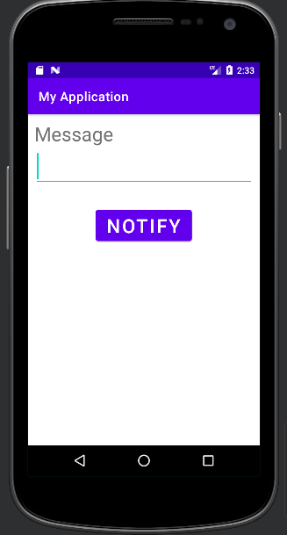
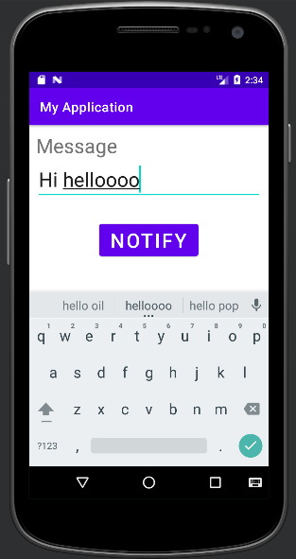
OUTPUT:
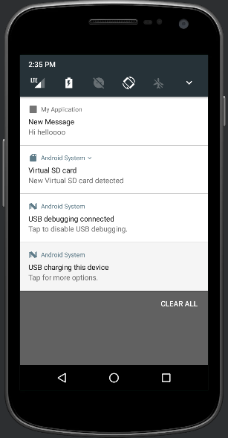

RESULT:
Thus Android Application that creates an alert upon receiving a message is developed and executed successfully.

SOURCE CODE:
MainActivity.java
packagecom.example.myapplication;
importandroid.app.AlarmManager;
importandroid.app.PendingIntent;
importandroid.content.Intent;
importandroid.os.Bundle;
importandroidx.appcompat.app.AppCompatActivity;
importandroid.view.View;
importandroid.widget.TimePicker;
importandroid.widget.Toast;
importandroid.widget.ToggleButton;
importjava.util.Calendar;
public class MainActivity extends AppCompatActivity
{
TimePickeralarmTimePicker;
PendingIntentpendingIntent;
AlarmManageralarmManager;
@Override
protected void onCreate(Bundle savedInstanceState)
{
super.onCreate(savedInstanceState);
setContentView(R.layout.activity_main);
alarmTimePicker = (TimePicker) findViewById(R.id.timePicker);
alarmManager = (AlarmManager) getSystemService(ALARM_SERVICE);
}
public void OnToggleClicked(View view)
{
long time;
if (((ToggleButton) view).isChecked())
{
Toast.makeText(MainActivity.this, "ALARM ON", Toast.LENGTH_SHORT).show();
Calendar calendar = Calendar.getInstance();
calendar.set(Calendar.HOUR_OF_DAY, alarmTimePicker.getCurrentHour());
calendar.set(Calendar.MINUTE, alarmTimePicker.getCurrentMinute());
Intent intent = new Intent(this, AlarmReceiver.class);
pendingIntent = PendingIntent.getBroadcast(this, 0, intent, 0);
time=(calendar.getTimeInMillis()-(calendar.getTimeInMillis()%60000));
if(System.currentTimeMillis()>time)
{
if (calendar.AM_PM == 0)
time = time + (1000*60*60*12);
else
time = time + (1000*60*60*24);
}
alarmManager.setRepeating(AlarmManager.RTC_WAKEUP, time, 10000, pendingIntent);
}
Else
{
alarmManager.cancel(pendingIntent);
Toast.makeText(MainActivity.this, "ALARM OFF", Toast.LENGTH_SHORT).show();
}
}
}

AndroidManifest.xml
<?xml version="1.0" encoding="utf-8"?>
<manifest xmlns:android="http://schemas.android.com/apk/res/android"
xmlns:tools="http://schemas.android.com/tools"
package="com.example.myapplication">
<application
android:allowBackup="true"
android:dataExtractionRules="@xml/data_extraction_rules"
android:fullBackupContent="@xml/backup_rules"
android:icon="@mipmap/ic_launcher"
android:label="@string/app_name"
android:roundIcon="@mipmap/ic_launcher_round"
android:supportsRtl="true"
android:theme="@style/Theme.MyApplication"
tools:targetApi="31">
<activity
android:name=".MainActivity"
android:exported="true">
<intent-filter>
<action android:name="android.intent.action.MAIN" />
<category android:name="android.intent.category.LAUNCHER" />
</intent-filter>
</activity>
<receiver android:name=".AlarmReceiver" >
</receiver>
</application>
</manifest>

AlarmReceiver.java
packagecom.example.myapplication;
importandroid.content.BroadcastReceiver;
importandroid.content.Context;
importandroid.content.Intent;
importandroid.media.Ringtone;
importandroid.media.RingtoneManager;
importandroid.net.Uri;
importandroid.widget.Toast;
public class AlarmReceiver extends BroadcastReceiver
{
@Override
public void onReceive(Context context, Intent intent)
{

Toast.makeText(context, "Alarm! Wake up! Wake up!",Toast.LENGTH_LONG).show();
Uri alarmUri = RingtoneManager.getDefaultUri(RingtoneManager.TYPE_ALARM);
if (alarmUri == null)
{
alarmUri = RingtoneManager.getDefaultUri(RingtoneManager.TYPE_NOTIFICATION);
}
Ringtone ringtone = RingtoneManager.getRingtone(context, alarmUri);
ringtone.play();
}
}
OUTPUT:
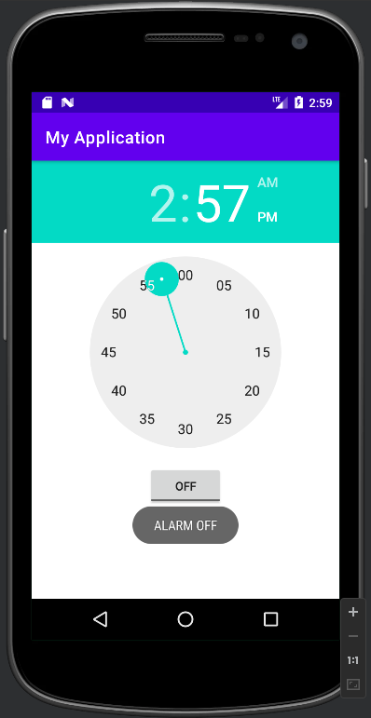
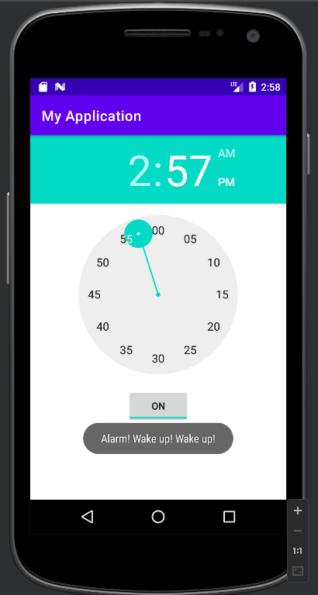

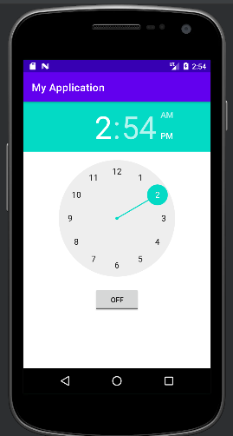

RESULT:
Thus, Android Application that creates Alarm Clock is developed and executed successfully.

SOURCE CODE:
MainActivity.java
package com.example.myapplication;import android.content.Intent;
import android.os.Bundle; import android.view.View; import android.widget.Button; import android.widget.EditText;
import androidx.appcompat.app.AppCompatActivity; public class MainActivity extends AppCompatActivity {
private EditText eTo; private EditText eSubject;private EditText eMsg; private Button btn; @Override
protected void onCreate(Bundle savedInstanceState) { super.onCreate(savedInstanceState);
setContentView(R.layout.activity_main); eTo = (EditText)findViewById(R.id.txtTo);
eSubject = (EditText)findViewById(R.id.txtSub);eMsg = (EditText)findViewById(R.id.txtMsg); btn = (Button)findViewById(R.id.btnSend); btn.setOnClickListener(new View.OnClickListener() { @Override
public void onClick(View v) {
Intent it = new Intent(Intent.ACTION_SEND); it.putExtra(Intent.EXTRA_EMAIL, new String[]{eTo.getText().toString()}); it.putExtra(Intent.EXTRA_SUBJECT,eSubject.getText().toString()); it.putExtra(Intent.EXTRA_TEXT,eMsg.getText()); it.setType("message/rfc822"); startActivity(Intent.createChooser(it,"ChooseMail App"));
}});
}

}

activity_main.xml:
<?xml version="1.0" encoding="utf-8"?>
<LinearLayout xmlns:android="http://schemas.android.com/apk/res/android" android:layout_width="match_parent"
android:layout_height="match_parent" android:paddingLeft="20dp" android:paddingRight="20dp" android:orientation="vertical" >
<EditText android:id="@+id/txtTo" android:layout_width="match_parent" android:layout_height="wrap_content" android:hint="To"/>
<EditText android:id="@+id/txtSub"
android:layout_width="match_parent" android:layout_height="wrap_content" android:hint="Subject"/>
<EditText android:id="@+id/txtMsg"
android:layout_width="match_parent" android:layout_height="0dp" android:layout_weight="1" android:gravity="top" android:hint="Message"/>
<Button android:layout_width="100dp" android:layout_height="wrap_content" android:layout_gravity="right" android:text="Send"

android:id="@+id/btnSend"/>
</LinearLayout>

AndroidManifest.xml
<?xml version="1.0" encoding="utf-8"?>
<manifest xmlns:android="http://schemas.android.com/apk/res/android" xmlns:tools="http://schemas.android.com/tools" package="com.example.exno11" >
<uses-permission android:name="android.permission.INTERNET" />
<application android:allowBackup="true" android:icon="@mipmap/ic_launcher"
android:label="@string/app_name" android:theme="@style/AppTheme" tools:ignore="GoogleAppIndexingWarning">
<activity android:name="com.example.myapplication.MainActivity"android:label="@string/app_name">
<intent-filter>
<action android:name="android.intent.action.MAIN" />
<category android:name="android.intent.category.LAUNCHER" />

<action android:name="android.intent.action.SEND"/>
<category android:name="android.intent.category.DEFAULT"/>
<data android:mimeType="message/rfc822"/>
</intent-filter>
</activity>
</application>
</manifest>

OUTPUT:
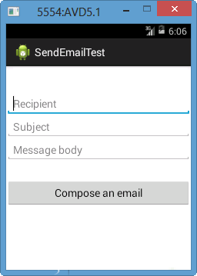
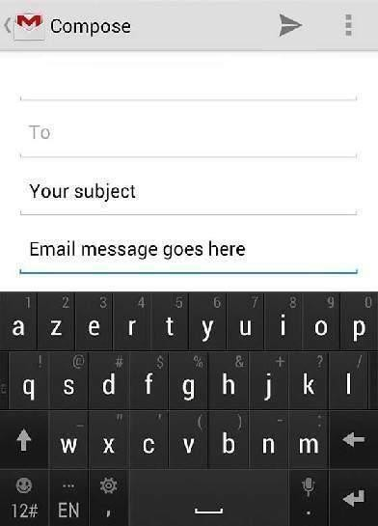

RESULT:
Thus Android Application for sending an email is developed and executed successfully.

